PAST PERFORMANCE TEMPLATES (BDG FEDERAL):

Contents

PAST PERFORMANCE TEMPLATES (BDG FEDERAL): 1
1.1 USDA OPPE: Web-based Economic Development & Strategic Planning Platform 2
1.1.1 CPARS: USDA OPPE 4
1.2 MD DHS: Agile Scrum Team Resources 6
1.3 OCTO: Data Architecture Support Services 8
1.4 USDA NAL: IT Library Support Systems Operations and Maintenance 9
1.4.1 CPARS: USDA NAL 12
1.5 FMSHRC: Cloud Hosting and Managed Services 13
1.6 HHS ASPR: Professional Administrative Staffing Support Services 13

1.1 USDA OPPE: Web-based Economic Development & Strategic Planning Platform
Client Name | US Department of Agriculture (USDA) Office Partnerships and Public Engagement (OPPE)
Prime or Subcontractor | Prime
Project Name | Web-based Economic Development & Strategic Planning Platform
Period of Performance | September 2020 – September 2022
Contract Value | $300,000.00
Contract Number | 12314420F0644
Client POC Details | Sean Jordan | sean.jordan2@wdc.usda.gov
Summary of Performance
Objectives: OPPE sought to establish a modern customer service platform storing diverse customer information. It prioritized peer-to-peer communication, networking tools, section 508 testing and integration, and collaboration for resource sharing. OPPE emphasized continuous support and technical assistance, incorporating feedback for ongoing improvements. Regular analysis, evaluation, and proactive updates were crucial for ensuring easy access and delivering robust customer service.

Solutions and Services Provided: vTech delivered a Web-based Economic Development and Strategic Planning Platform for OPPE, aimed at bolstering USDA's capacity for fostering public and private partnerships. The platform focused on providing education and resources to promote hope, opportunity, wealth creation, and asset building in rural and underserved communities. Our seasoned Drupal website development team meticulously addressed USDA's requirements outlined in the PWS, with regards to creating a new website or refreshing an existing one. We efficiently developed, customized, and migrated large-scale applications to Drupal within the allocated budget and timeline adhering to USDA's stringent schedule. With an Agile development approach, our Drupal developers crafted innovative web solutions that aligned with user, business, and industry needs, as well as the specific requirements of the agency. Additionally, comprehensive documentation was prepared at each project stage to facilitate a seamless transition for USDA teams. Team vTech conducted a thorough evaluation of requirements, ensuring the timely delivery of a Drupal website solution that perfectly met USDA's goals in terms of functionality and mobile readiness.
Key features of vTech’s solutions and services include the following:
- Cloud Support - We successfully implemented the Web-based Economic Development and Strategic Planning Platform on Microsoft Azure, providing continuous support for cloud hosting solutions. Our team conducted a thorough business readiness assessment, determining the optimal method for replicating the workforce IT infrastructure on Microsoft Azure. This assessment encompassed a gap analysis, consideration of Recovery Time Objective (RTO) and Recovery Point Objective (RPO) requirements, and an analysis of the existing network's bandwidth usage.
- Registration and Profile Management - We developed a centralized profile management system for OPPE communities and partners, storing crucial profile information and facilitating its prompt delivery to end-users nationwide, upon request. The system incorporated features such as failure recovery, migration support, and Key Performance Indicator (KPI) improvement capabilities.
- Tiered Access Management - We proposed a three-tiered administrative model for privileged credentials. The highest level, Tier 0, encompassed the Domain Controller, holding privileged accounts, groups, devices, and domains capable of managing all domains. Tier 0 Administrators had interactive access to Tier 0 devices and could oversee all tiers and assets. Tier 1 included domain member servers and applications, while Tier 2 was designated for end-users. This three-tiered structure facilitated access for USDA customers and personnel, enabling collaboration with communities on asset mapping and strategic planning.
- Automation of Tasks – We enabled Auto Recommendations by drawing on our Artificial Intelligence (AI) and Machine Learning capabilities. By doing so, we delivered personalized recommendations tailored to the preferences and tastes of all partners across all touchpoints. With this support, OPPE managed the platform's day-to-day operations and made recommendations to strengthen components of the USDA community.
- AI Chatbots - USDA has incorporated opportunity zones to attract enduring investments into low-income communities, fostering economic activity and job creation. OPPE employed its website as the focal point for a cross-departmental initiative concentrating on outreach, capacity building, and technical assistance. The initiative aimed to bolster economic and project development in rural and underserved communities. To address capacity limitations, a strategic emphasis was placed on functional skill development, encompassing asset mapping, strategic planning, and coalition building. Additionally, automated tools were deployed to assess and enhance the website's accessibility. vTech’s Managed Security Services delivered end-to-end cybersecurity solutions that took a preventive security approach rather than a traditional detect-and-respond methodology. For OPPE, we used a stack of leading security technologies to protect network, cloud, mobile, and enterprise applications against zero-day threats with 24×7 monitoring and proactive threat management.
Results: We developed a Web-Based Economic Development and Strategic Planning Platform for USDA OPPE, addressing the need for a contemporary customer service platform with features like peer-to-peer communication and networking tools. Our team was able to work in a challenging environment with changing priorities and assignments. Because the project was extended and a quick turnaround was required, we used a flexible development method combined with security services to create a web platform for USDA OPPE. This approach saved money, helped us use resources wisely, and allowed for ongoing improvements.

Relevance to Proposed Scope
Services provided in this project included Drupal website development, Microsoft Azure cloud support, registration, profile management, discussion boards, tiered access, task automation, AI chatbots, and managed security. These services match the scope of the proposed project in terms of {insert two or three services the client needs that were provided to USDA OPPE in this past performance, e.g. application development and cloud support}.

1.1.1 CPARS: USDA OPPE
CPARS: Web-based Economic Development & Strategic Planning Platform
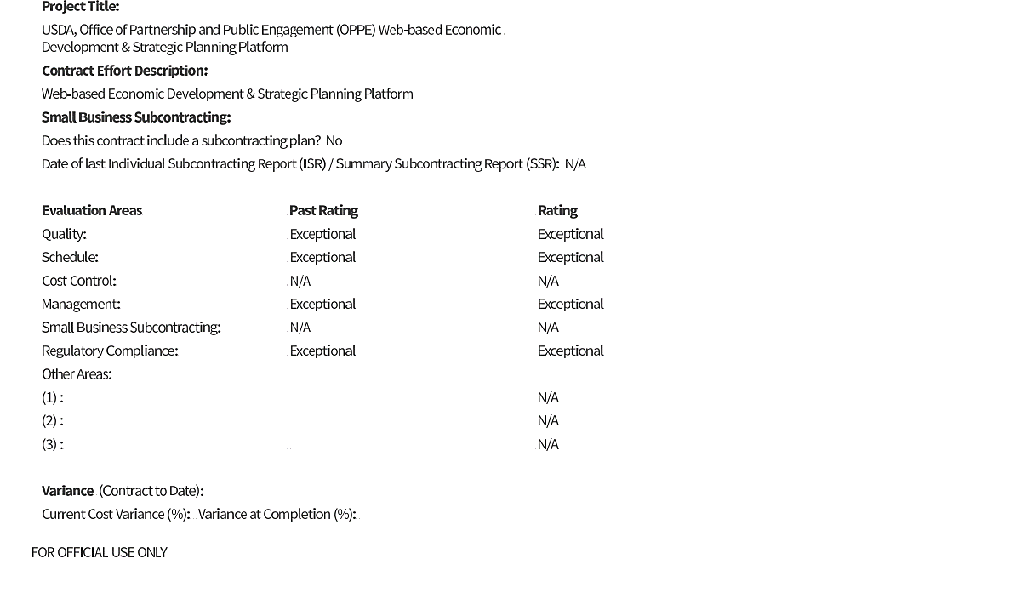

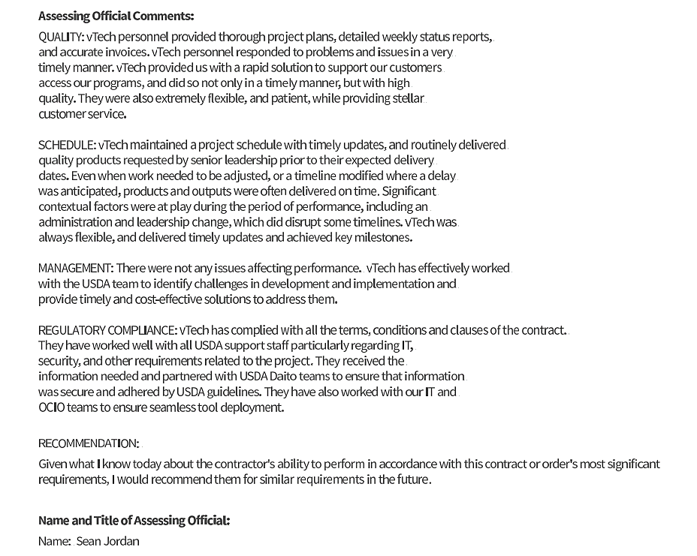

1.2 MD DHS: Agile Scrum Team Resources
Client Name | Maryland Department of Human Services (DHS)
Prime or Subcontractor | Prime
Project Name | Agile Scrum Team Resources
Period of Performance | 4/28/2018 - to date
Contract Value | $4,370,000.00
Contract Number | N00B8400064
Client POC Details | Jim Jones | jamese.jones@maryland.gov
Summary of Performance
Objectives: MD DHS sought to transition from its existing application platform to the new “MDTHINK” platform. MDTHINK is an innovative, cloud-based platform that allows multiple state agencies to share and manage data in one convenient place. The vision of MDTHINK was to open the floodgates for endless volumes of data to flow into the system. Because of the inefficient data structure in place, DHS was facing a challenge: the inability to provide a unified view of essential information which was causing inadequacies and hindering cross-department communication and decision-making.

Solutions and Services Provided: vTech made an exhaustive study of the DHS's project specifications and drafted a tailor-made solution. We reviewed and evaluated the various data sources of 24 local agencies and analyzed the conversion steps required. All the redundant and existing data were converted using ETL processes. Custom queries and SQL scripts were created to manipulate the data into the required format. Our team conducted system testing and provided troubleshooting to quickly and accurately find solutions to resolve issues. Stringent data security and compliance measures such as HIPAA, IRS 1075, MARS-E, FISMA and NIST were applied to maintain the confidentiality of data. Rather than a centralized repository of data, we implemented an Enterprise Data Model (EDM). Our EDM facilitated the integration of data and reduced data silos. Our data visualization experts utilized a variety of tools to ensure the data was represented in a clear, concise, and consistent manner, allowing DHS to fully leverage it for the MDTHINK platform.
In this effort, we developed an application based on Java technology and related frameworks. We had a team of comprised of the following personnel: subject matter experts (SMEs), Training specialists, Business analyst, Product administrator, full stack Java developers, Product specialists, UI/UX designers, ForgeRock engineers, Informatica MDM architect, Data analyst, Qlik developer, Security governance consultant, Conversion ETL developer, Hadoop administrator, DevOps engineer, Tester, Reporting developer, Application developer, Corticon developer, Solution architect.
The vTech team carried out the following tasks:
- Assisted in the system integration of components.
- Translated application requirements into web-based solutions using the recommended frameworks and technology.
- Integrated the components using Web Services, EJB, REST SOAP, and other techniques.
- Designed and implemented responsive web application user interfaces using JavaScript/CSS/HTML5/jQuery.
- Designed and developed wireframes or prototypes based on requirements and validated the design with users.
- Implemented Continuous Integration/Continuous Delivery (CI/CD) which was integral for the scope of the MDTHINK platform and to facilitate quick, fast, and multiple iterative deployments.

Results: A centralized reference data management system had significant advantages in providing accurate, timely, and consistent data across MD DHS systems. This resulted in a considerable reduction in reconciliation activities and increased the efficiency and effectiveness of various teams. Most importantly, enhanced data analytics enabled state agencies to deliver the highest levels of service to Marylanders. It also provided an integrated solution for eligibility determination, financial management, and resource management that readily shares data and reuses proven systems and business functions. As a seasoned IT team, vTech utilized industry best practices, frameworks, and federal mandates, like Agile Scrum, Agile SAFE, ITIL, FedRAMP, FISMA, NIST, ATO, and Section 508.

Relevance to Proposed Scope
This project is ongoing and shares similarities to the scope of the proposed project in terms of {insert two or three services the proposed client needs that were also provided in this past performance, e.g. modernization and enhancement of existing applications}.

1.3 OCTO: Data Architecture Support Services
Client Name | Office of the Chief Technology Officer (OCTO)
Prime or Subcontractor | Subcontractor
Project Name | Data Architecture Support Services
Period of Performance | January 2018 – January 2020
Contract Value | $2,335,925.76
Contract Number | CW77447
Client POC Details | James Detherage | jdetherage@obverse.net
Summary of Performance
Objectives: OCTO frequently partners with technology consultants and has a broad scope of strategic objectives. To that end, OCTO sought data architecture support to perform operation and maintenance (O&M) of logical data models, as well as mitigate risks in the implementation of a master data management strategy.

Solutions and Services Provided: vTech provided Database (DB) & Architecture Support Services by undertaking the following:
- Planned, organized, and implemented Database & Architecture support projects to assist the district’s growing information needs.
- Ensured the effective use of district resources by contributing to policies for effective process planning as it relates to new requirements.
- Provided expert knowledge of the Structured Query Language (SQL) environment with specific emphasis on analysis, design, and implementation of reports and report interfaces intended for the end user participating in short-term tactical planning implementation in master data management strategy.
- Worked on critical Oracle database systems which included tasks like database patching, testing, designing, and planning for Oracle database deployment.
- Monitored database issues; conducted maintenance, backup, and disaster recovery support for the production, testing, staging, and development of Oracle databases; implemented database support for data warehousing environments and other business applications using Oracle as the database platform.
- Designed and developed activities for implementation of Oracle Enterprise Manager 12c including the installation of new monitoring database modules for enterprise applications such as PeopleSoft 9.2.
- Conducted database administration and management which included the creation of data and data dictionaries.
One of the deliverables for this project required vTech to architect and design technical solutions for the modernization of applications, advanced and secure networks and cloud initiatives based on industry standards and best practices. We were responsible for designing technology components for enterprise solutions and defining solution architectures and reference architectures with a focus on cloud technologies.

Results: vTech successfully provided Database and Architecture support that helped OCTO to serve its customers more effectively. With our support, OCTO attained extended hardware lifecycle, reduced storage-related maintenance costs, and deferred capital expenditure. vTech’s managed data architecture empowered OCTO's employees at all levels to extract valuable insights from data that are necessary to achieve business goals and propel OCTO’s success. vTech successfully steered the expansion of the dc.net services to the local government, ensuring that the public always stays well-informed.

Relevance to Proposed Scope
These services share similarities with the scope of the proposed project in terms of {insert two or three services the proposed client needs that were provided in this past performance, e.g. Digital Asset Management at the federal level}.

1.4 USDA NAL: IT Library Support Systems Operations and Maintenance
Client Name | U.S. Department of Agriculture (USDA) National Agricultural Library (NAL)
Prime or Subcontractor | Prime
Project Name | IT Library Support Systems Operations and Maintenance
Period of Performance | 09/30/2022 – 09/29/2026
Contract Value | $1,008,975.00
Client POC Details | Sherry Panzer | Sherry.Panzer@usda.gov | 301.504.1074
Summary of Performance
Objectives: USDA NAL was seeking a contractor with solid experience and expertise to support operations and maintenance (O&M) of NAL’s web applications at the highest levels of user experience. The required support needed to employ the following:
- Industry best practices tools and techniques such as (ISO) 20000, ISO 9000 ITIL, and the Project Management Body of Knowledge (PMBOK)
- Innovative techniques such as Remote Process Automation (RPA), a maintenance process using the latest 508 requirements, and a digital playbook to assess the applications of NAL.
- Key skills and requirements for supporting application systems, including troubleshooting, modifying, maintaining, and enhancing NAL web applications.
NAL’s main objective was to establish standard Change Management Processes for creating, reviewing, approving, scheduling, and implementing changes within the Information Systems Division (ISD) systems and technical environment for ongoing O&M support.

Solutions and Services Provided:
Application Support: vTech provided comprehensive support for NAL systems and implemented cutting-edge technologies for ongoing Project Management of NAL’s O&M and updates to NAL applications and web services. Our expert team supported the entire Change Request process, including minor enhancements and defects for applications, systems, and web/application services. We leveraged automation and streamlined processes to improve operational efficiency and effectiveness. In addition, we proactively engaged in troubleshooting and resolved issues with applications in NAL's development, staging/testing, and production environments. To maintain and enhance application performance, we carried out a full range of activities, including analysis, design, programming, and documentation. We also implemented strict security measures to protect the applications from any potential threats. Our team designed and executed rigorous unit and user tests to validate the quality and effectiveness of the applications.
Operations and Maintenance: vTech performed Application Operations and Maintenance (AOM) for continuous update analysis, modification, and re-evaluation of NAL's existing processes and web applications. Some best practices we used include making and following a maintenance schedule, prioritizing issue fixing, testing the maintenance updates, verifying the testing results, and outsourcing the application maintenance. With comprehensive data collection, intelligent log analysis, and event reporting, AOM enabled O&M personnel to locate, identify, and analyze problems across NAL infrastructure and achieve rapid, easy setup. All distributed applications were scrutinized in one place with customizable exception detection policies, trigger modes, alarm rules, and monitoring APIs.
vTech used the Information Technology Infrastructural Management (ITIL) framework to help the organization and all sectors solve business issues, improve IT capability, and implement new capabilities that directly provide business value. We engaged the ITIL framework to meet USDA’s IT challenges and offered integrated task management which provided significant value to NAL. vTech's support provided quality services and efficient IT solutions to 20,000 USDA end-users across 10 regions, as well as an additional 2,000+ end users in other areas. Per USDA’s requirements, we provided support with troubleshooting issues within NAL applications and reporting through NAL ticketing systems. As part of the ITIL 4 framework, vTech supported USDA across the five ITIL areas: service strategy, service design, service transition, service operation, and continual service improvement.
Additionally, we followed the ITIL Service Value Chain, enabling us to provide meticulous services in six steps:
- Plan: Our wide-ranging services and operation management culminated in the delivery of a one-stop solution for initiating, recording, and resolving all incidents as requested in the project’s SOW. Keeping in mind the expected functions and services, we created a tailored Information Technology Service Management (ITSM) plan to satisfy USDA NAL which included effective task management, timely handling of service requests, and proper tracking of tickets. We implemented AI to resolve the requests automatically.
- Engage: We communicated regularly with the respective stakeholders from multiple federal departments, contractors, and vendors in support of operations. We collaborated with federal managers to provide an exceptional customer experience with quality assurance.
- Design and Transition: We prepared Service Level Agreements (SLAs) and deliverables and shared them with relevant team members to attain a mutual understanding of the agreed requirements. These included the prioritization of others’ work, quality assurance, performance management, monitoring and escalation of tickets, and operational status reports that satisfied the compliance requirements of the agency.
- Obtain/Build: We ensured that the agreed specifications were met. We implemented robust Standard Operating Procedures (SOPs) which provided an overall picture of what was being implemented, upgraded, and maintained, and allowed policies and procedures to be updated accordingly. The procedures involved a work-based hierarchy, requirements, outputs, criteria to measure success, project management, and security-related information.
- Deliver and Support: We stayed in continuous collaboration with dedicated USDA officers to create, perform, and review the quality and timeliness of deliverables. These included the provision of efficient, end-to-end NAL O&M support and services as defined in the SLA; analysis, testing, implementation, enhancement, and maintenance initiated through the project’s GitHub repository database; planned deliverables; a Program Management Plan; and Continuous IT Service Improvements.
- Improve: We ensured the continual improvement of ongoing services by analyzing the service improvement and productivity improvement plans. We leveraged AI agents to resolve requests on time to achieve cost-effectiveness and increased productivity. These agents assisted in the resolution of requests such as troubleshooting application issues, responding to tickets, and enhancing the project’s GitHub repository.

Results: vTech successfully provided USDA NAL with O&M support, task management support, and development, maintenance, and implementation of NAL applications. Our high-quality services fully met the requirements of the agency and helped them meet their mission.

Relevance to Proposed Scope
vTech provided application modernization, operation, and maintenance which resulted in streamlined, cost-effective outcomes for NAL. Our services enhanced the gathering and evaluation of user requirements and delivered graphical user interface elements like menus and widgets. These services match the scope of the proposed project in terms of {insert two or three services the proposed client needs that were provided in this past performance, e.g. project management, application user interface/user experience (UI/UX), process design, surge support, information assurance and effective documentation needs}.

1.4.1 CPARS: USDA NAL
CPARS: IT Library Support Systems Operations and Maintenance
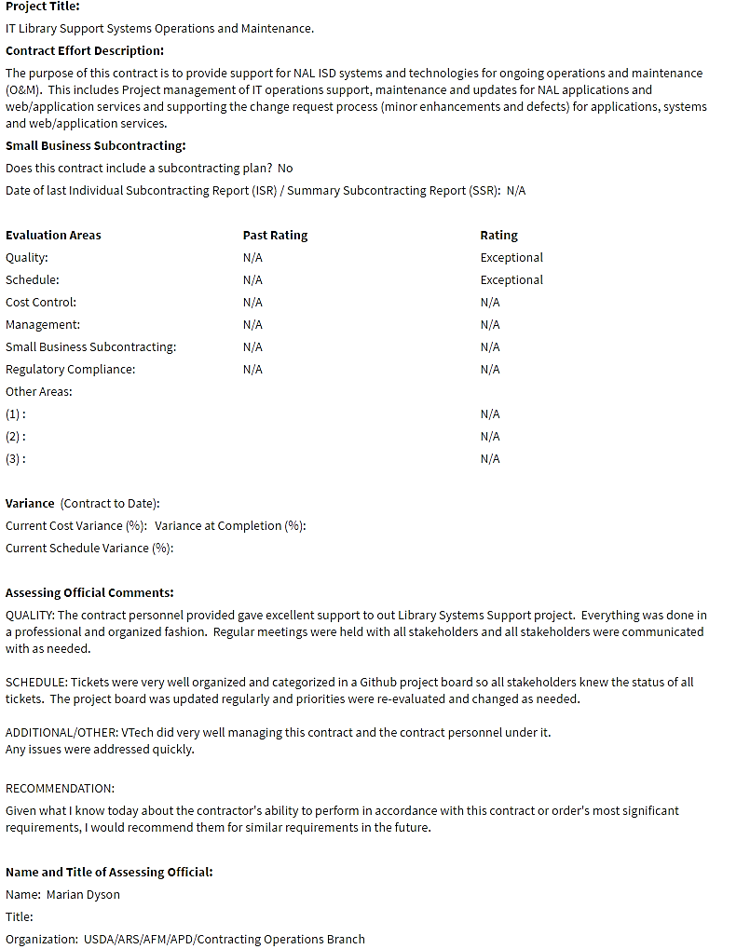

1.5 FMSHRC: Cloud Hosting and Managed Services
Client Name | Federal Mine Safety and Health Review Commission (FMSHRC)
Prime or Subcontractor | Prime
Project Name | Cloud Hosting and Managed Services
Period of Performance | 08/01/2023 - 07/31/2024
Contract Value | $586,790.00
Contract Number | RFP-MSC-IT-23-0009
Client POC Details | Matthew Richards
Summary of Performance
Objectives: Within FMSHRC, the Office of the Executive Director (OED) and the Office of Information Technology (OIT) sought a capable IT vendor for daily cloud hosting and managed services to oversee the agency's website management.

Solutions and Services Provided: In response to FMSHRC's challenges, vTech stepped in to provide a comprehensive suite of professional cloud hosting and managed services. This suite addressed FMSHRC's requirements with precision. It encompassed ongoing support for cloud infrastructure, Drupal administration, limited Drupal content management, OS administration, database administration, disaster recovery, OS hardening, basic security compliance documentation, and managed services. This holistic approach ensured that vTech met FMSHRC's needs cohesively and effectively.

Results: Through its partnership with vTech, FMSHRC has achieved significant milestones in enhancing its IT infrastructure and support capabilities. Our team at vTech successfully provided cloud hosting and managed services, ensuring FMSHRC's website remained operational and FISMA compliant. The migration of the website to a secure cloud-hosted environment, along with the implementation of robust disaster recovery resources, has fortified FMSHRC's online presence, ensuring uninterrupted access for website visitors. Additionally, our network services, application management, and security compliance support have further bolstered FMSHRC's IT capabilities, enabling the commission to fulfill its mission while adhering to stringent security standards efficiently. Ultimately, this endeavor was driven by FMSHRC's commitment to providing accessible, secure, and up-to-date information to benefit the nation's mining industry and workforce, reflecting its dedication to safety and compliance for the well-being of all citizens.

Relevance to Proposed Scope
These services match the scope of the proposed project in terms of {insert two or three services the proposed client needs that were provided in this past performance, e.g. migration and hosting of existing applications (Drupal)}.

1.6 HHS ASPR: Professional Administrative Staffing Support Services
Client Name | Department of Health and Human Services (HHS) Office of the Assistant Secretary for Preparedness and Response (ASPR)
Prime or Subcontractor | Subcontractor
Project Name | Professional Administrative Staffing Support Services
Period of Performance | 9/29/2022 – 9/29/2024
Contract Value | Cumulative Value of all Subcontractor Task Order(s)
Contract Number | 75A50121D00003
Client POC Details | Bryce Space and Technology, LLC (BryceTech)  Nathan Sanders | nathan.sanders@brycetech.com | 703-945-3261
Summary of Performance
Objectives: HHS ASPR required assistance with the staffing of administrative support services, technical services, and medical services.

Solutions and Services Provided: BryceTech was awarded Contract Number 75A50121D00003 on September 30, 2021, with the US Department of Health and Human Services (HHS), Office of the Assistant Secretary for Preparedness and Response (ASPR) (the “Client” or “Government”) to acquire Professional Administrative Staffing Support Services (the “Prime Contract”).
Results: vTech is currently active in this effort and helping the ASPR program ramp up its federal staff.

Relevance to Proposed Scope
These services match the scope of the proposed project in terms of {insert two or three services the proposed client needs that were provided in this past performance, e.g. IT Professional Services provided at the Federal level for additional Surge Support}.

